Tutorial 00 01a
Tutorial 00 – Motionbuilder UI
Familiarise yourself with Autodesk Motionbuilder with the youtube video below:
https://youtu.be/WlB57cTsu4w
Tutorial 01 01
Getting used to Characterised Fbx Skeletons and Mocap:
https://youtu.be/tYtavnjsOGo
Mocap Files:
Tutorial Files 01 Mocap Only.zip
- Open Motionbuilder and Start new scene from top left File Menu
- Arrange your layout to suit with Navigator, Resources, Viewer, and Character Controls Windows Only - REQUIRES YOU TO HOLD DOWN SHIFT
  - Drag Resources top right
  - Drag Navigator top right below resources
  - Close animation layers
  - Close animation key controls
  - Keep timeline at bottom across whole UI
  - Keep Character Controls full right

https://gyazo.com/71d8f34e36846f6fd73a5770f1bcf882
https://gyazo.com/1d25fc1ace67356803610a01b09940c2
- From Resources/Asset Browser Tab/Tutorials Folder/, Drag a Mia Blue into the scene (Fbx Open/No Animation)
- From Resources/Asset Browser Tab/Templates Folder/Characters Folder/, Drag a Character Template over any part of Mia and drop
- Select Characterise in the pop-up
- Check Mia is facing positive Z and click Biped
- Find in navigator under Characters and rename to Character Mia
- At top menu on Left, select File/Merge
- Select Waiter Idle.fbx from Google Drive link of mocap files above
- Accept all Defaults and click Merge

https://gyazo.com/32c1caa1703448ad535e349fedaa3b71
- Select Takes in dropdown menu in Transport Controls Window to see new and old takes (Take 001 and Waiter Idle)
- In navigator expand the Scene Folder by clicking the “+” sign.
- Find, select, and delete the Cameras, Markers, and unnamed markers in Scene Folder.
  - Right Click on System Folder and click “Select Branches”
    - Right Click, Select Delete/Confirm
  - Right Click on “Unnamed Markers” and click “Select Branches”
    - Right Click, Select Delete/Confirm
- You should be left with the mocap fbx skeleton and named optical markers
  - Select Display/XRay at top of Viewer to view bones
- Check framerate at bottom far right of Transport Controls (select 30 in this case)
- (Frame 0 – type 0 into start frame to eliminate 0* - Important)
Also change 894* to 894
Avoid moving the blue spheres that adjust the transport window – this shrinks the transport view
- Characterise mocap Fbx Skeleton on Tpose at Frame 0
- Rename Character as Character Mocap
- In Character window, with Character Mia as Character, select Character Mocap as Source.
- Playback and check the mocap Drives Mia, Note the scale differences
Tutorial 01 02
Adjustments, Floor Plane, Control Rig
https://youtu.be/M5tQt9b1aD4
- Look at Property tabs in Navigator with Characters/Character Mia selected
- Select Character in Navigator window, look at Property tabs for Character Definition, Character Settings
- Character Settings Tab – Look at Inputs – Check Stance and Active tickbox (for all changes we make!)
- Most of the Same controls are duplicated in the Character Controls Window we just used.
- Adjust IK Blend (Reach) and Pull – IK Blend moves toward source, Pull brings the rest along - Example:. https://youtu.be/d8DDPImlp9s
- IK (Inverse Kinematics) is animation propagating up a skeleton (wrist moves elbow), FK (Forward Kinematics) is just the individual bone rotating.
- Adjust head IK Blend, T, and R, then IK Pull when IK Blend is active
- In Character Settings Tab, try match source and action space compensation.
- Adjust Hands and other body parts for IK Blend T,R and Pull in Character Settings and also Character Controls windows. See the correlation and effect.
- Check feet – they are below the floor
- In Character Settings tab, make sure character is on stance (not Tpose!), then untick active box
- In Character Definition tab, untick characterize box
- Check Character Controls Window for green bones (correct stance)
- Drag in Plane object from Asset Browser/Templates/Elements/
- Type 0, 0, 0 in bottom right of viewing pane
- Alt-drag the plane into the four spots on below the reference node mapping box in Character Definition
- Tick Characterize button, accept Biped
- In Character Settings, modifiers/floor contact, select always sync in drop down box
- Tick feet floor contact and toes floor contact
- Scale up feet contact size to 300
- Change foot front to 8
- Change foot outside to 8
- Click active box while in stance input
- Change source to character mocap
- Check foot plane works by hitting t key and translating plane up and down.
Tutorial 01 03
Importing More Mocap, adjusting with Control Rig In Story.
https://youtu.be/x0pfv5YWTvg

- Clean up scene in navigator to just have Fbx
- Select Fbx Solving Skeleton in Navigator and right click select branches
- At top left select Motion File Import and import with Merge/In Selected Models only and all tick boxes selected except for create unmatched models
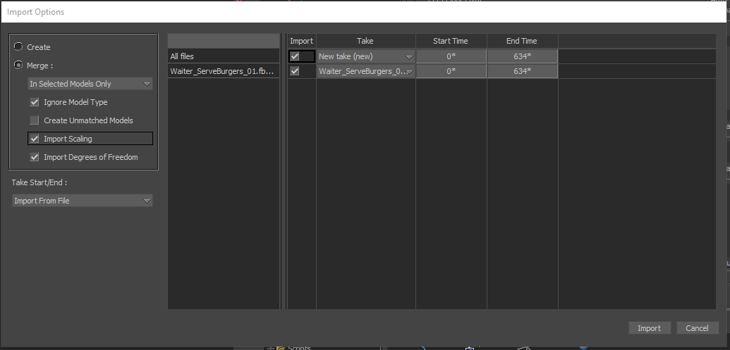
https://gyazo.com/b5d23cc99234ea3386c559da635bbc0f
- Change start frame from 0* to 0 and also clean up end frame
- Check fps = 30
- In Takes drop-down box in Transport bar, select and check different takes of motion
- In Story Mode, insert Character Animation Track and select Character Mia in Drop down box reference
- In Character Settings, Plot Character to Control Rig for Adjustments in Story
- Select FK/IK and 30 fps
- Name Control Rig as Control Rig Mia
- Try IK Blend and Pull to move skeleton - Example: https://youtu.be/d8DDPImlp9s
- In story right click in story track and insert current take
- Story Overrides all live animation! Control rig is plotted
- Can mute story and change source to go back to mocap
- Can switch takes, plot back to same control rig, add to second Story track
  - Plot will capture from start and end frames of transport control!!!
  - Can move animations
  - Plot only between the start and end frames of takes – check!
  - Plots to transport position – keep at 0 when plotting
  - Plot to different tracks to adjust individually
- Try back and forth with a few animations. Try to catch any pitfalls.

